**ROS1 instructions**

|  |  |  |  |  |
| --- | --- | --- | --- | --- |
| Version | Revised Date | General Version | Description | Editor |
| v1.0.1 | March.8.2023 | v1.0.1 |  | ysy |

Contents

1. Compilation & packaging 3

1.1 Compile 3

1.1.1 Package file directory structure 3

1.1.2 Catkin compile 4

1.2 packaging 4

2. Instructions 4

2.1 ros deb Installation and uninstallation 4

2.2 ros package calling explanation 5

2.3 catkin workspace use synexens-ros-driver 5

2.4 synexens-ros-drive provided topic 5

2.5 synexens-ros-driver provided parameters functions 5

3. Note 5

3.1 The depian/postinst Post-processing script 5

3.2 SDK dependency library file placement 6

3.3 Some notes about compiling between different ROS versions 7

# Compilation & packaging

## Compile

### Package file directory structure

Synexens_ROS_Driver

├── CMakeLists.txt

├── debian

│   └── postinst

├── docs

├── ext

│   └── sdk

├── include

│   ├── lib

│   ├── opencv

├── include

│   └── synexens_ros_driver

│   ├── synexens_calibration_transform_data.h

│   ├── synexens_ros_bridge_nodelet.h

│   ├── synexens_ros_device.h

│   ├── synexens_ros_device_params.h

│   └── synexens_ros_types.h

├── launch

│   ├── driver.launch

│   └── viewer.launch

├── nodelet_plugins.xml

├── package.xml

├── README.md

├── rviz

│   └── view.rviz

├── scripts

│   └── synexens-usb.rules

└── src

├── synexens_calibration_transform_data.cpp

├── synexens_ros_bridge_node.cpp

├── synexens_ros_bridge_nodelet.cpp

├── synexens_ros_device.cpp

└── synexens_ros_device_params.cpp

Core code file：include/synexens_ros_driver/*.h, src/*.cpp 🡪 Realize main node functions

Core package file：package.xml, nodelet_plugins.xml, CMakeLists.txt 🡪ROS Core package file

SDK Dependency：ext/sdk/ 🡪 Synexens SDK Dependency library

ROS Executive document：launch/*_launch🡪 For the launch command

Rviz Visualization file：rviz/*.rviz 🡪File used to record rviz UI format

USB rules: scripts/ synexens-usb.rules 🡪 Synexens USB Device Permission Modification

Debian package installation post-processing file: Debian/the postinst 🡪 Debian packaging after installation of post-processing file, used to install the USB rules

### Catkin compile

Copy Synexens_ROS_Driver to workspace catkin_ws/src file ;

$ cd catkin_ws/src

$ catkin_make

## packaging

In addition to compiling using catkin_make, you can also package ros packages using debian. Can refer to https://zhuanlan.zhihu.com/p/380545893

**Operations as follows:**

1) Run the following command to install the utilities required for compilation (build):

$ sudo apt-get install python-bloom fakeroot

2) Run the following command to compile and build the debian package

$ cd /path/to/pkg_source # this should be the directory that contains the package.xml

$ bloom-generate rosdebian

$ fakeroot debian/rules binary

# Instructions

## ros deb Installation and uninstallation

Installation: $ sudo apt install ./ros-[ROS_DISTRO]-synexens-ros-driver_[Version]-0bionic_amd64.deb

Uninstallation: $ sudo dpkg --purge ros-melodic-synexens-ros-driver

## ros package calling explanation

1）**Start only** Synexens ROS Driver: $ roslaunch synexens_ros_driver driver.launch

2）**Start** Synexens ROS Driver和rviz: $ $ roslaunch synexens_ros_driver viewer.launch

## catkin workspace use synexens-ros-driver

$ cd catkin_ws

$ source ./devel/setup.bash

$ roslaunch synexens_ros_driver driver.launch

If the catkin workspace can be compiled, but the library is missing, copy all the.so files that the sdk relies on to the catkin_ws/devel/lib/ directory, and try again.

## synexens-ros-drive provided topic

- `points2` (`sensor_msgs::PointCloud2`)

- `rgb/image_raw` (`sensor_msgs::Image`)

- `rgb/camera_info` (`sensor_msgs::CameraInfo`)

- `depth/image_raw` (`sensor_msgs::Image`)

- `depth/camera_info` (`sensor_msgs::CameraInfo`)

- `ir/image_raw` (`sensor_msgs::Image`)

## synexens-ros-driver provided parameters functions

ROS provides the parameter server function [ROS Parameters] of configuring parameters at startup. ( <http://wiki.ros.org/Parameter%20Server> )，

We have defined some parameters that can be configured at launch.

For details, please refer to driver.launch file.

# Note

## The depian/postinst Post-processing script

1) Because the script fails to automatically find the location of the synexens-ros-driver package during execution, the commands for installing USBs. usb.rulues need to be manually modified in different versions of postinst. This can be optimized later.

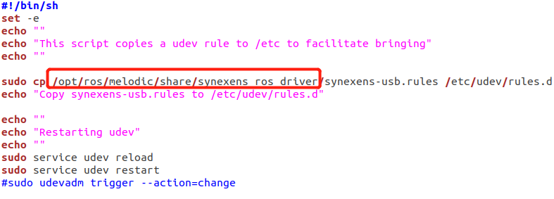

2) Ubuntu20.04 failed to run udev restart

When udev reload is run in the Ubuntu20.04 script, udev restart displays an error, so this section is commented in Ubuntu20.04. This section updates the permission information of the usb device. If the usb camera cannot be opened successfully due to permission problems, you can run the following command in the red box on the terminal to refresh the permission of the device.

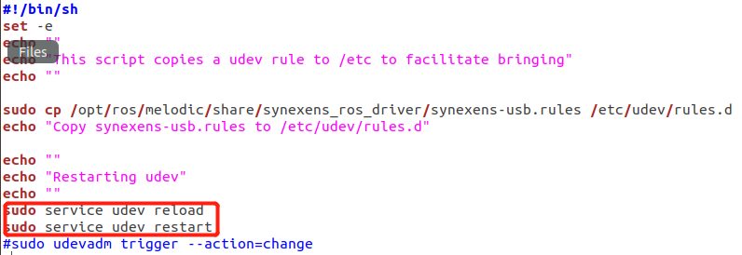

## SDK dependency library file placement

If platforms of different versions depend on the SDKS of platforms of different versions, you need to manually copy the sdk files according to the above file directories. If you have Cmake writing experience, you can run the Cmake command to automatically copy files to ext/sdk/.

Note: linux SDKS are best packaged in tar to preserve executable permissions and soft links to library files.

## Some notes about compiling between different ROS versions

At present, the compilation, code parts and other core package files of different ros versions do not need to be changed, but the following modifications need to be made:

1. Only depian/postinst needs to be modified according to different ros versions, specifically modified according to Section 3.1.

2. The corresponding version of the sdk library needs to be copied. For details, see Section 3.2.